Smart SDLC – AI Enhanced Software Development Lifecycle

## Introduction

**Project Title**: Smart SDLC AI Enhanced Software development Lifecycle

**Smart SDLC** is a cutting-edge, generative AI-powered application that reimagines how developers and learners engage with the software development lifecycle. Built using **FastAPI** and leveraging **IBM’s Granite-3.3-2b-instruct** model, this platform provides intelligent, phase-by-phase assistance throughout the SDLC.

Whether you're navigating requirements analysis, design, coding, testing, or maintenance, Smart SDLC offers contextual guidance, intelligent automation, and adaptive learning support to enhance productivity and ensure adherence to best practices. It's not just a tool—it’s a digital engineering companion that brings smart automation and domain knowledge into your development workflow.

With Smart SDLC, the future of software engineering is faster, smarter, and more accessible to all.

## Team Members and their Roles:

* 1. **B. Bogendra Babu (Project Lead, Full Stack Developer, AI/NLP Specialist):**
     + **Designed overall architecture, developed Stream-lit front-end for modules.**
     + **Coordinated AI integration and back-end planning.**
     + **Final integration of all SDLC modules.**
     + **Integrated Open-AI/Gemini API s for chat-bot, implemented AI for requirement generation, code, and test cases.**
     + **Planned WatsonX/Granite integration.**
  2. **B. Anvesh Babu (Frontend Developer):**
     + **Designed UI for Login, Dashboard, and Wizard pages.**
     + **Implemented dark/light theme toggle.**
     + **Assisted with navigation and page routing.**
  3. **B. Khyathi Priyanshu (Authentication & Database Developer):**
     + **Developed login using Stream-lit.**
     + **Set up SQLite database for users, chat logs, requirements, and feedback.**
     + **Managed schema creation and storage logic.**
  4. **B. Chinnama Naidu (Data & Feedback Analyst):**
     + **Implemented sentiment analysis using Text-blob.**
     + **Designed feedback form and analytic dashboard.**
     + **Created Plot visualizations for feedback trends.**

1. **Project Overview**

### Purpose:

Smart SDLC is a generative AI-powered application developed using Fast-API and IBM's Granite-3.3-2b-instruct model. It provides phase-wise assistance across the Software Development Life-cycle (SDLC), enabling developers and learners to understand and implement software engineering practices through intelligent automation.

### Features:

Phase-wise AI chatbot (Gradio-powered) Generates code, test cases, design suggestions Secure login and admin dashboard

Sentiment analysis and feedback tracking Local and Colab-based deployment

1. **Architecture Frontend:**

* Stream-lit used for main user interface and SDLC modules.
* Gradio and Jinja2 templates used for chatbot UI and rendering static pages.

### Backend:

* Fast-API server with Restful endpoints handling login, registration, dashboard, chat, and feedback processing.

### Database:

* SQLite used to manage user sessions, chat history, requirements, and sentiment-tracked feedback.

# Setup Instructions

### Prerequisites:

Python 3.10+, FastAPI, Uvicorn, Gradio, SQLite, langchain-ibm, Jinja2

### Installation:

git clone <repo-url> pip install -r requirements.txt uvicorn app:app --reload

# Folder Structure

### Client:

Contains Gradio and Jinja templates in /templates/

### Server:

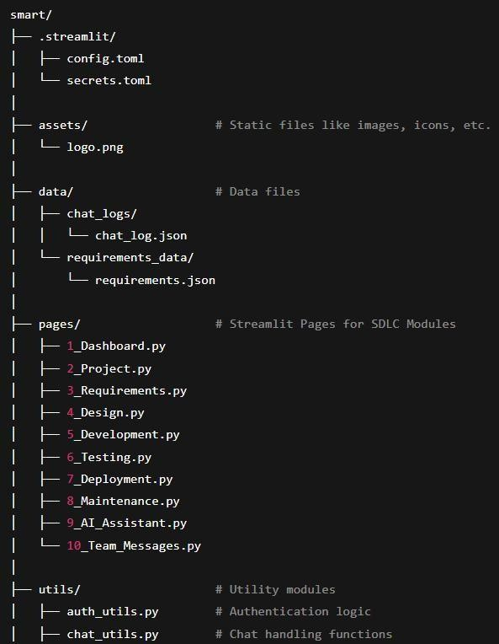FastAPI logic, routes, and processing in app.py

# Running the Application

### Front-end:

Access the app at [http://127.0.0.1:8000](http://127.0.0.1:8000/)

### Back-end:

Start with:

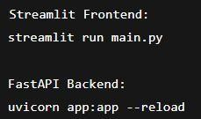uvicorn app:app --reload

# API Documentation

### Endpoints:

/, /login, /register, /dashboard, /chat, /feedback, /admin

### Details:

Accepts JSON requests

Uses sessions and cookies for tracking

Returns structured responses for UI rendering and analytics

# Authentication

### Security:

User login/register with session-based token handling Admin dashboard available only to authorized users

# User Interface

Built using Gradio and Colab templates Admin dashboard includes visual analytics Chat interface shows context-based AI ponses

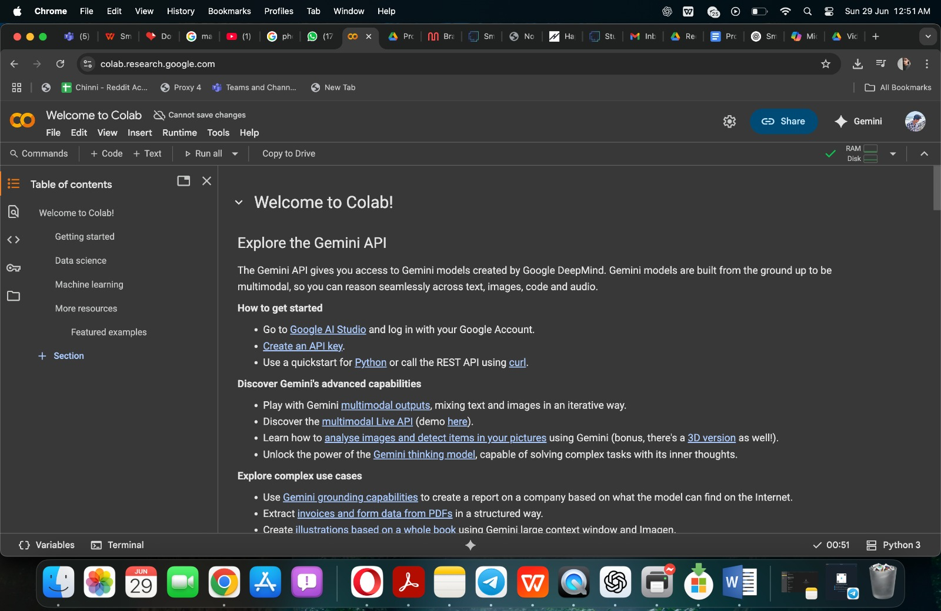

**Chatbot AI -Assitent:**

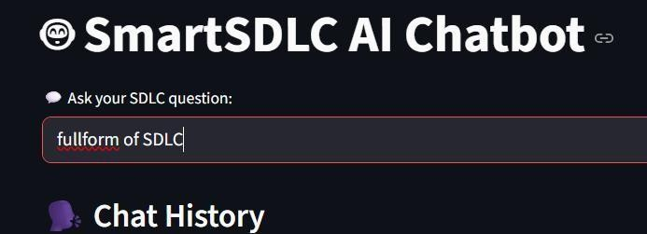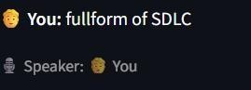

**Feedback Analysis:**

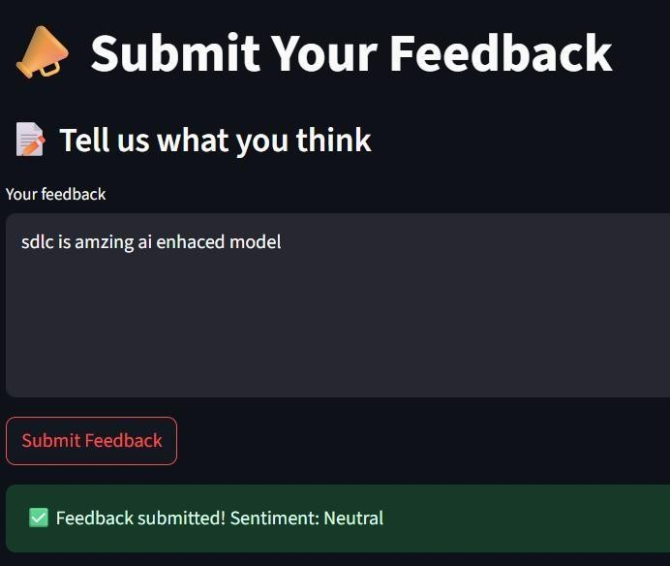

# Purpose

Smart SDLC was built to address the inefficiencies and manual overhead in traditional software development lifecycles by embedding AI assistance in each phase. Its purpose is to:

Provide real-time, contextual support using natural language.

Automate repetitive development tasks like writing boilerplate code, creating test cases, and drafting documentation.

Enable learners and non-technical users to grasp SDLC concepts interactively. Enhance consistency and quality of outputs across the development process.

**Traditional SDLC vs Smart SDLC (AI-Powered)**

Aspect Traditional SDLC Smart SDLC (AI-Enhanced)

Requirement Gathering

Manual meetings, user stories

AI generates requirement specifications

Design

Diagrams and documents prepared manually

AI suggests design structures and components

Development

Written entirely by developers

AI provides code templates/snippets

Testing

Test cases manually written AI generates test cases and edge

and run scenarios

Deployment Planned by DevOps/PM

AI recommends deployment strategies/tools

Maintenance

Reactive to bugs and user feedback

AI gives refactoring and optimization guidanc

# Testing

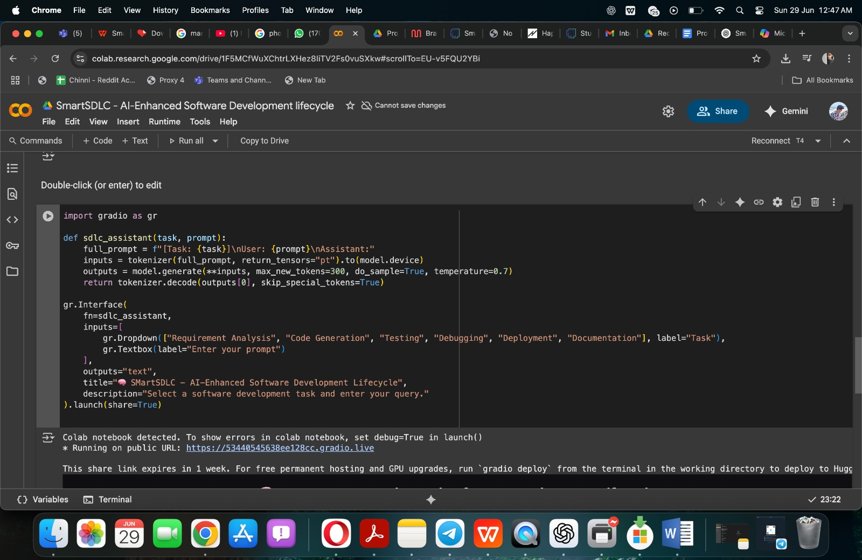

Manual testing for all SDLC phases Sentiment logging and feedback tested

Dummy user data tested through complete flow

# Importance of Smart SDLC

**Time-Saving**: Automates documentation, test case generation, and boilerplate code.

**Educational Value**: Helps students understand phase-wise breakdown and implementation.

**Increased Consistency**: Reduces human errors in documentation and coding. **Prototyping Power**: Startups can quickly ideate, test, and refine product concepts. **Decision Support**: Offers suggestions based on patterns and prior interactions.

1. **Demo link:**

[**https://drive.google.com/file/d/1gNtlSFI1oqrCaWfV1cmkV95Ic3wKRRcN/view?usp=drivesdk**](https://drive.google.com/file/d/1gNtlSFI1oqrCaWfV1cmkV95Ic3wKRRcN/view?usp=drivesdk)

**Reliance on Prompts**: AI output quality heavily depends on how queries are phrased.

**Generalization**: May not generate production-ready solutions for complex enterprise needs.

**No Real-Time Collaboration**: Currently not multi-user or team-oriented.

**Limited Integration**: Doesn't yet support third-party tools like Postman or GitHub Actions.

**Data Privacy**: AI models may not be suitable for use with sensitive or proprietary data.

## Known Issues

-Varying AI response quality with vague prompts.

* + Admin dashboard insights are dependent on sufficient feedback data.
  + Occasional token/session expiry during long idle periods.

## Future Enhancements

Add support for generating architecture diagrams Export project plans and reports in PDF Integration with CI/CD pipelines

API testing and mock server integration

Use LangChain to chain prompts for better AI conversations

Export project reports, charts, and summaries as downloadable PDFs Integrate CI/CD pipelines (e.g., GitHub Actions, Jenkins)

Add Postman-ready APIs and support for OpenAPI 3.0 Add team collaboration with multi-user chat & versioning

Add JWT or OAuth2-based secure token-based authentic

**Project Development Phase**

**Model Performance Test**

|  |  |
| --- | --- |
| Date | 10 February 2025 |
| Team ID | LTVIP2025TMID32163 |
| Project Name | Smart SDLC – AI Enhanced Software Development Lifecycle |
| Maximum Marks |  |

**Model Performance Testing:**

Project team shall fill the following information in model performance testing template.

|  |  |  |  |
| --- | --- | --- | --- |
| **S.No.** | **Parameter** | **Values** | **Screenshot** |
|  | Model Summary | **-** |  |
|  | Accuracy | Training Accuracy -   Validation Accuracy - |  |
| 3. | Fine Tunning Result( if Done) | Validation Accuracy - |  |

**Project Design Phase-II**

**Data Flow Diagram & User Stories**

|  |  |
| --- | --- |
| Date | 31 January 2025 |
| Team ID | LTVIP2025TMID32163 |
| Project Name | Smart SDLC – AI Enhanced Software Development Lifecycle |
| Maximum Marks | 4 Marks |

### **Data Flow Diagram (DFD) – Smart SDLC**

A **Data Flow Diagram (DFD)** is a graphical representation that illustrates how information flows within the **Smart SDLC** system. It visually maps how data enters the application, how it is processed using AI, where it is stored, and how it is delivered back to the user.

For **Smart SDLC**, which is developed using **FastAPI** and powered by **IBM’s Granite-3.3-2b-instruct model**, the DFD helps in clearly understanding the interaction between users, system components, and data transformation across the **Software Development Life Cycle (SDLC)**.

The DFD effectively captures:

* **Inputs**: User queries, SDLC phase selection, project context
* **Processes**: FastAPI-based request handling, AI model interaction, prompt processing
* **Storage**: Temporary session data or user history (optional for personalized flow)
* **Outputs**: AI-generated phase-wise guidance and SDLC recommendations

By presenting this information flow visually, the DFD ensures stakeholders and developers can quickly grasp **how Smart SDLC operates**, from user input to intelligent output, enabling better design, debugging, and future enhancements.

Example: DFD Level 0 (Industry Standard)

**Example:** [**(Simplified)**](https://developer.ibm.com/patterns/visualize-unstructured-text/)

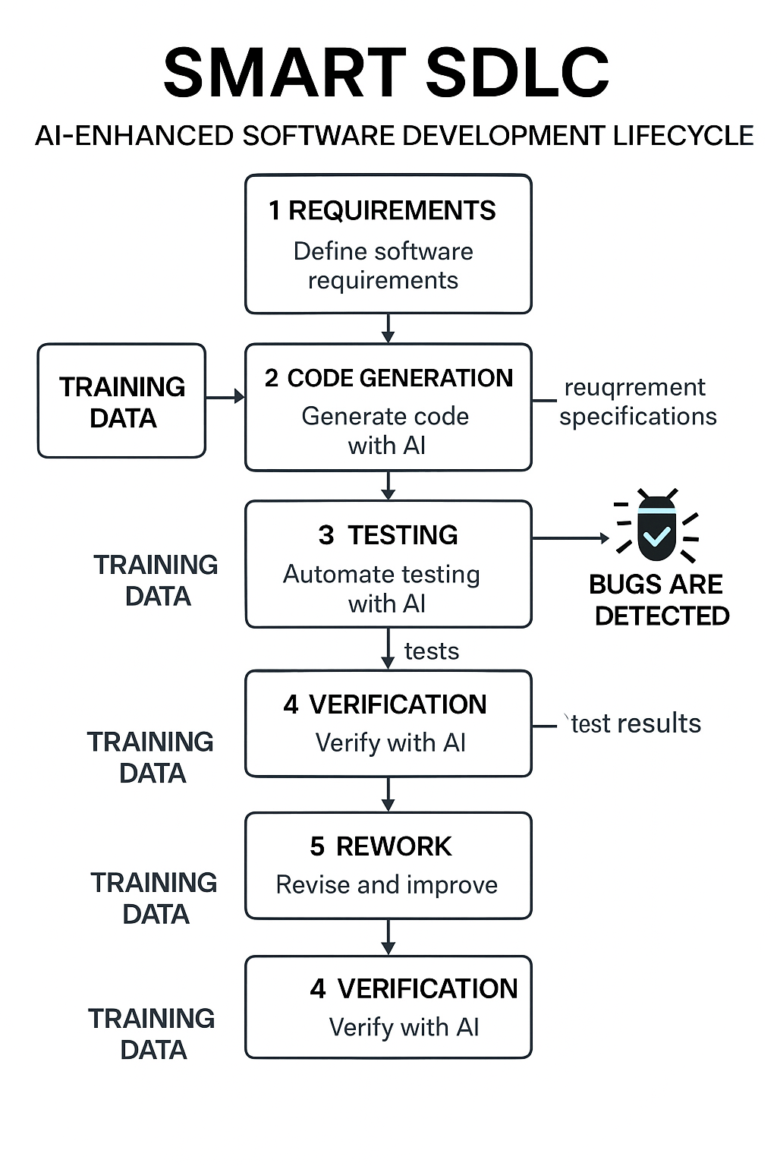

Here’s the **User Stories Table** customized for the **Smart SDLC** application, following the given format:

### ✅ **User Stories – Smart SDLC**

| **User Type** | **Functional Requirement (Epic)** | **User Story Number** | **User Story / Task** | **Acceptance Criteria** | **Priority** | **Release** |
| --- | --- | --- | --- | --- | --- | --- |
| Developer (Web user) | Registration & Onboarding | USN-1 | As a user, I can register and create a Smart SDLC account using my email and password. | Account is created; redirected to dashboard | High | Sprint-1 |
|  |  | USN-2 | As a user, I will receive a confirmation email after successful registration. | Email is received and confirmation link is functional | High | Sprint-1 |
|  |  | USN-3 | As a user, I can register using my GitHub or Google account. | Able to sign in and access dashboard via OAuth | Medium | Sprint-2 |
| Developer (Web user) | SDLC Guidance (Phase-wise) | USN-4 | As a user, I can select an SDLC phase (e.g., Design) to get AI-generated assistance. | AI generates relevant guidance for selected SDLC phase | High | Sprint-1 |
|  |  | USN-5 | As a user, I can enter project-specific input for phase-wise suggestions. | Personalized AI suggestions are displayed | High | Sprint-1 |
|  |  | USN-6 | As a user, I can view formatted AI responses in a readable output panel. | Outputs are clean, structured, and phase-specific | Medium | Sprint-2 |
| Developer (Web user) | Dashboard | USN-7 | As a user, I can view all previous queries and AI responses organized by SDLC phases. | Past queries/responses visible per session | Medium | Sprint-2 |
| Administrator | User Management | USN-8 | As an admin, I can manage (view, delete, update) user accounts. | Admin panel functions as expected | Medium | Sprint-3 |
| Admin/Developer | Analytics & Logs | USN-9 | As an admin, I can view usage statistics for each SDLC module (phases used, traffic, etc.). | Analytics dashboard displays real-time stats | Low | Sprint-4 |
| Educator | Learning Mode | USN-10 | As a mentor, I can switch the app to a learning mode with simpler AI prompts for students. | A toggle activates student-friendly content generation | Medium | Sprint-3 |

**Ideation Phase**

**Define the Problem Statements**

|  |  |
| --- | --- |
| Date | 31 January 2025 |
| Team ID | LTVIP2025TMID32163 |
| Project Name | Smart SDLC – AI Enhanced Software Development Lifecycle |
| Maximum Marks | 2 Marks |

### **Customer Problem Statement Template: Smart SDLC**

**Understand your users’ perspective and build AI-powered software development experiences they’ll value.**

Smart SDLC is a generative AI-powered application built using FastAPI and IBM's Granite-3.3-2b-instruct model. It offers intelligent, phase-wise assistance across the Software Development Life Cycle (SDLC), empowering developers, educators, and learners with guided insights and automation.

A well-crafted customer problem statement helps your team focus on solving the right challenges in modern software development. Smart SDLC addresses these challenges by simplifying SDLC practices, reducing manual effort, and making engineering knowledge more accessible through AI.

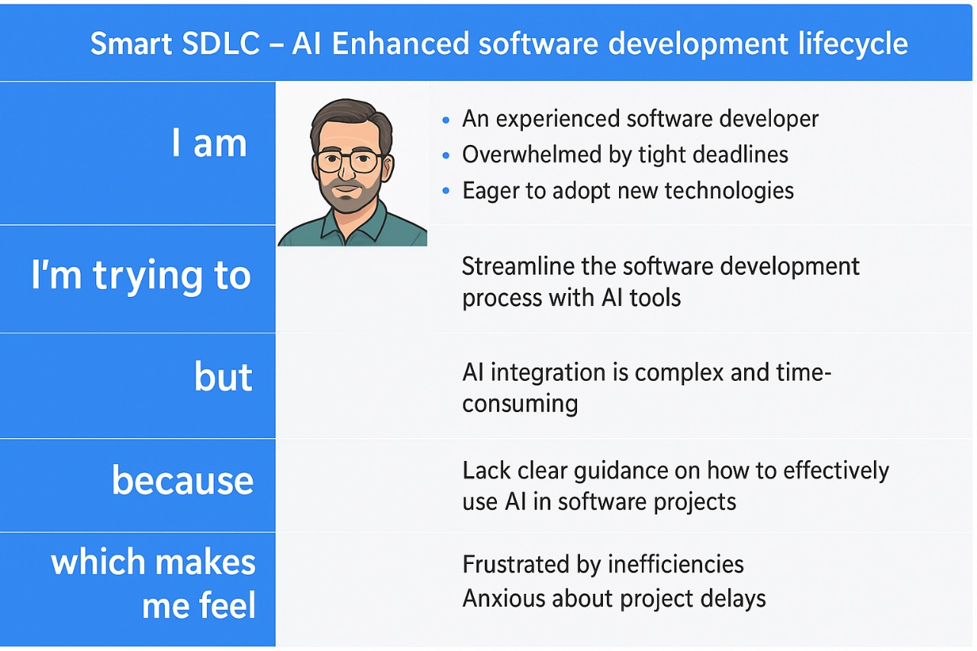

Reference: <https://miro.com/templates/customer-problem-statement/>

**Example:**

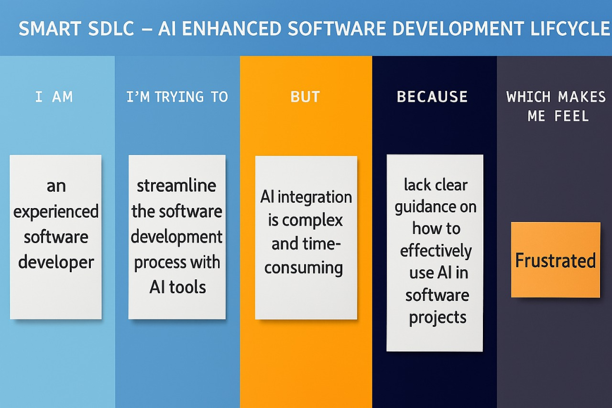

|  |  |  |  |  |  |
| --- | --- | --- | --- | --- | --- |
| **Problem Statement (PS)** | **I am (Customer)** | **I’m trying to** | **But** | **Because** | **Which makes me feel** |
| PS-1 |  |  |  |  |  |
| PS-2 |  |  |  |  |  |

**Ideation Phase**

**Empathize & Discover**

|  |  |
| --- | --- |
| Date | 31 January 2025 |
| Team ID | LTVIP2025TMID32163 |
| Project Name | Smart SDLC – AI Enhanced Software Development Lifecycle |
| Maximum Marks | 4 Marks |

### **Empathy Map Canvas: Smart SDLC**

An **empathy map** is a powerful, visual tool that captures what developers and learners **think**, **feel**, **say**, and **do** during the software development process. It helps your team gain a deeper understanding of user motivations, frustrations, and needs—so you can build solutions that resonate.

Smart SDLC is a generative AI-powered application built using **FastAPI** and **IBM's Granite-3.3-2b-instruct model**, offering real-time, phase-wise assistance across the Software Development Life Cycle (SDLC). It’s designed to support developers, learners, and teams by delivering intelligent automation and contextual guidance at every stage of development.

Creating an empathy map for Smart SDLC helps your team walk in the users’ shoes, enabling you to design features and support that solve real-world software development pain points.

**Example:**

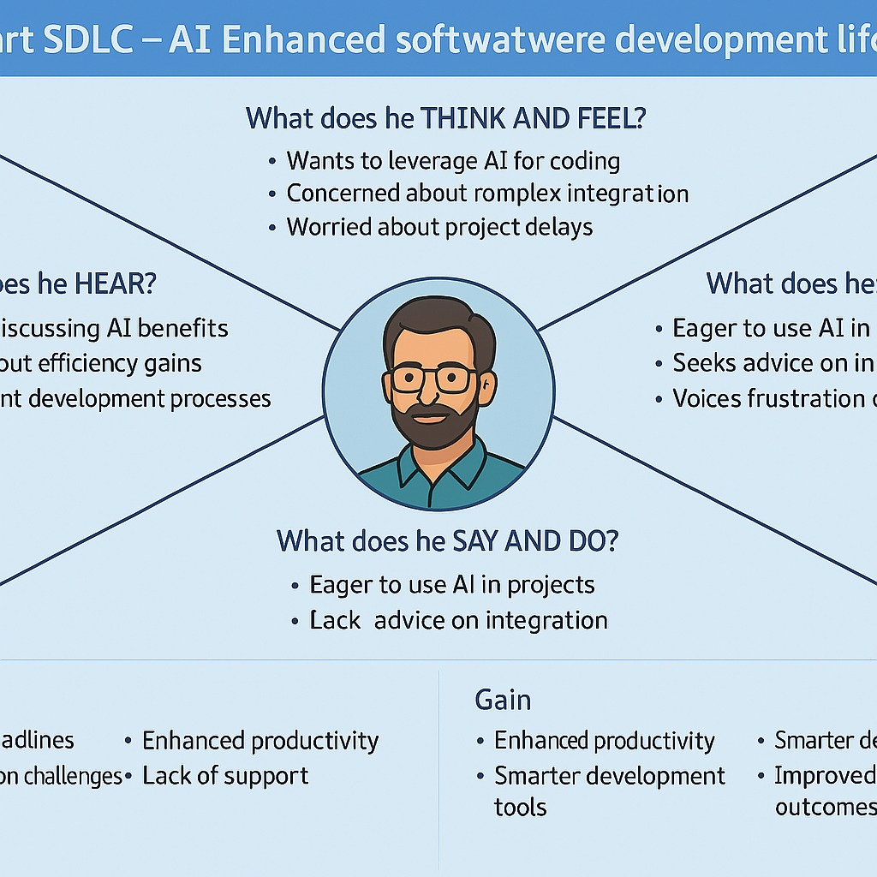

Reference: <https://www.mural.co/templates/empathy-map-canvas>

**Example: Food Ordering & Delivery Application**

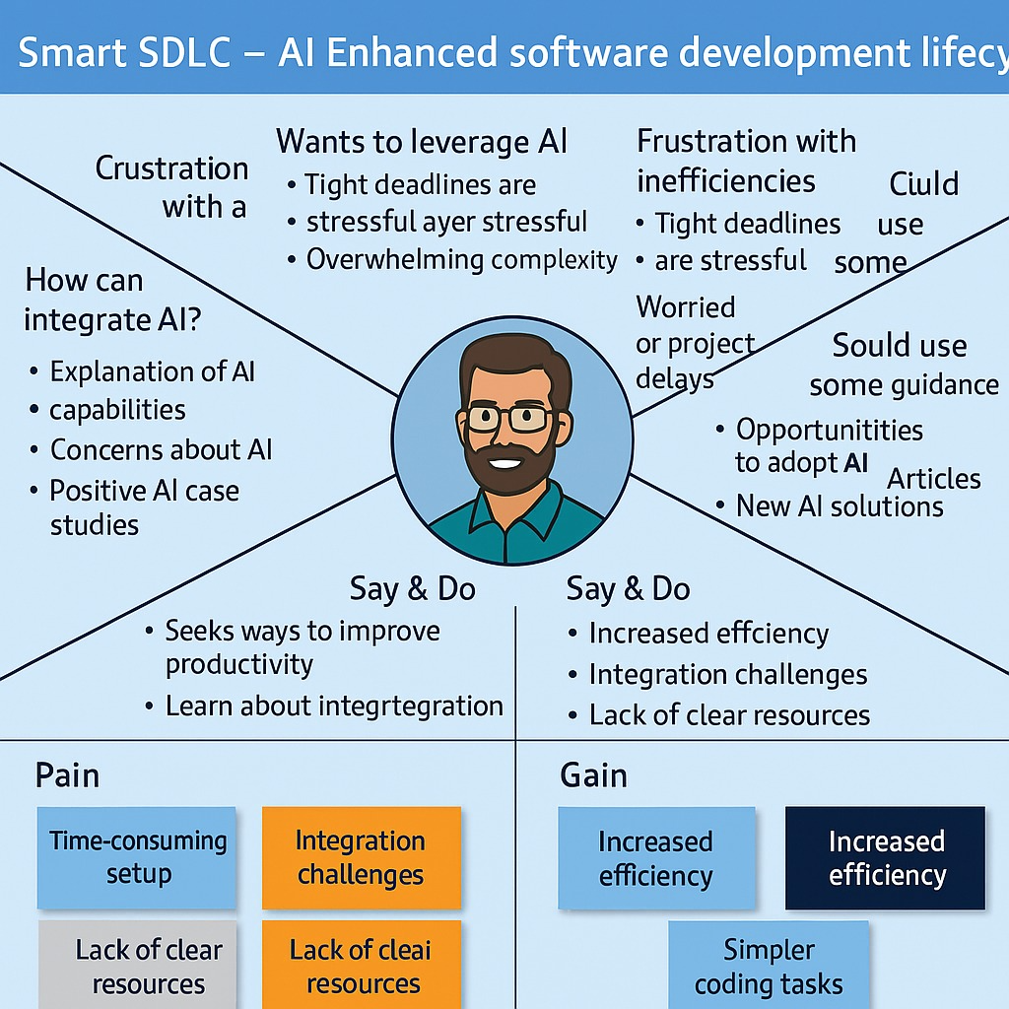

# **Functional & Performance Testing Template**

**Model Performance Test**

|  |  |
| --- | --- |
| Date | 21 February 2025 |
| Team ID | LTVIP2025TMID32163 |
| Project Name | Smart SDLC – AI Enhanced Software Development Lifecycle |
| Maximum Marks |  |

## **Test Scenarios & Results**

|  |  |  |  |  |  |
| --- | --- | --- | --- | --- | --- |
| **Test Case ID** | **Scenario (What to test)** | **Test Steps (How to test)** | **Expected Result** | **Actual Result** | **Pass/Fail** |
| **FT-01** | Text Input Validation (e.g., topic, job title) | Enter valid and invalid text in input fields | Valid inputs accepted, errors for invalid inputs |  |  |
| **FT-02** | Number Input Validation (e.g., word count, size, rooms) | Enter numbers within and outside the valid range | Accepts valid values, shows error for out-of-range |  |  |
| **FT-03** | Content Generation (e.g., blog, resume, design idea) | Provide complete inputs and click "Generate" | Correct content is generated based on input |  |  |
| **FT-04** | API Connection Check | Check if API key is correct and model responds | API responds successfully |  |  |
| **PT-01** | Response Time Test | Use a timer to check content generation time | Should be under 3 seconds |  |  |
| **PT-02** | API Speed Test | Send multiple API calls at the same time | API should not slow down |  |  |
| **PT-03** | File Upload Load Test (e.g., PDFs) | Upload multiple PDFs and check processing | Should work smoothly without crashing |  |  |

### **Agile Overview: Sprint-Based Breakdown for Smart SDLC**

* **Sprint:** A fixed period during which the team works to complete specific tasks.
* **Epic:** A large development objective (like a major feature or phase), broken into smaller tasks across sprints.
* **Story:** A small, manageable task that contributes to an Epic.
* **Story Point:** A numerical estimate (usually in Fibonacci series) representing the effort required to complete a story.

**Fibonacci-based Effort Scale:**  
1 – Very Easy  
2 – Easy  
3 – Moderate  
5 – Difficult

### **Sprint 1: (5 Days)**

**Epic: SDLC Guidance Core Setup**

* Build SDLC Phase Templates – 2
* Integrate FastAPI Backend – 3

**Epic: AI Model Integration**

* Connect to IBM Granite-3.3-2b-instruct – 5
* Define Prompt Templates – 2

**Sprint 1 Total Story Points = 12**

### **Sprint 2: (5 Days)**

**Epic: Frontend Interface**

* UI for SDLC Phase Navigation – 3
* Input/Output Components – 2

**Epic: Testing & Deployment**

* Local Testing & API Debugging – 3
* Deployment to Cloud (Render/Azure) – 5
* Basic User Guide or Tutorial Page – 2

**Sprint 2 Total Story Points = 15**

### **Velocity Calculation**

* **Total Story Points:** 12 (Sprint 1) + 15 (Sprint 2) = **27**
* **Number of Sprints:** 2
* **Velocity:** 27 ÷ 2 = **13.5 story points per sprint**

🔹 **Your team's velocity is 13.5 Story Points per Sprint.**  
This metric helps you estimate how much work your team can handle in future sprints while developing and scaling Smart SDLC.

Top of Form

Bottom of Form

**Project Design Phase**

**Problem – Solution Fit Template**

|  |  |
| --- | --- |
| Date | 15 February 2025 |
| Team ID | LTVIP2025TMID32163 |
| Project Name | Smart SDLC – AI Enhanced Software Development Lifecycle |
| Maximum Marks | 2 Marks |

### **Problem – Solution Fit: Smart SDLC**

The **Problem–Solution Fit** is the validation that the issue faced by your target users (developers, learners, educators, or team leads) is real and frequent — and that your solution, Smart SDLC, directly addresses it in a meaningful, adoptable way.

### **Purpose of this Fit for Smart SDLC**

✅ Solve **complex software development challenges** by matching your solution with the actual behavior and needs of developers.  
✅ Increase **adoption** by meeting users where they already are — in development environments where SDLC often gets neglected.  
✅ Sharpen your **product positioning and messaging** by focusing on pain points that matter most in everyday coding, planning, and testing workflows.  
✅ Build **trust** by solving frequent frustrations — such as lack of clarity, repetitive manual tasks, and misaligned SDLC practices.  
✅ Help users move from theory to action by understanding their **existing knowledge gaps** and tooling limitations.

**Template:**

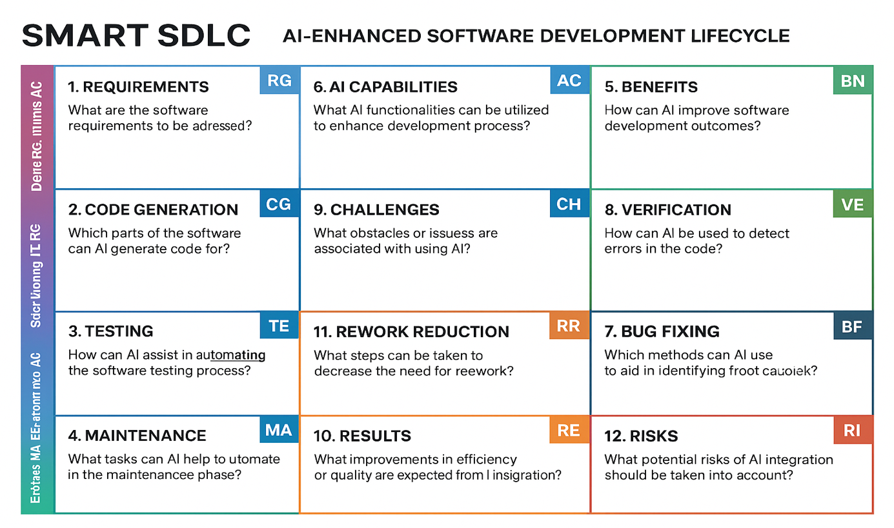

References:

1. <https://www.ideahackers.network/problem-solution-fit-canvas/>
2. <https://medium.com/@epicantus/problem-solution-fit-canvas-aa3dd59cb4fe>

**Project Planning Phase**

**Project Planning Template (Product Backlog, Sprint Planning, Stories, Story points)**

|  |  |
| --- | --- |
| Date | 15 February 2025 |
| Team ID | LTVIP2025TMID32163 |
| Project Name | Smart SDLC – AI Enhanced Software Development Lifecycle |
| Maximum Marks | 5 Marks |

**Product Backlog, Sprint Schedule, and Estimation (4 Marks)**

Use the below template to create product backlog and sprint schedule

| **Sprint** | **Functional Requirement (Epic)** | **User Story Number** | **User Story / Task** | **Story Points** | **Priority** | **Team Members** |
| --- | --- | --- | --- | --- | --- | --- |
| Sprint-1 | Registration | USN-1 | As a user, I can register for the application by entering my email, password, and confirming my password. | 2 | High |  |
| Sprint-1 |  | USN-2 | As a user, I will receive confirmation email once I have registered for the application | 1 | High |  |
| Sprint-2 |  | USN-3 | As a user, I can register for the application through Facebook | 2 | Low |  |
| Sprint-1 |  | USN-4 | As a user, I can register for the application through Gmail | 2 | Medium |  |
| Sprint-1 | Login | USN-5 | As a user, I can log into the application by entering email & password | 1 | High |  |
|  | Dashboard |  |  |  |  |  |
|  |  |  |  |  |  |  |
|  |  |  |  |  |  |  |

**Project Tracker, Velocity & Burndown Chart: (4 Marks)**

| **Sprint** | **Total Story Points** | **Duration** | **Sprint Start Date** | **Sprint End Date (Planned)** | **Story Points Completed (as on Planned End Date)** | **Sprint Release Date (Actual)** |
| --- | --- | --- | --- | --- | --- | --- |
| Sprint-1 | 20 | 6 Days | 24 Oct 2022 | 29 Oct 2022 | 20 | 29 Oct 2022 |
| Sprint-2 | 20 | 6 Days | 31 Oct 2022 | 05 Nov 2022 |  |  |
| Sprint-3 | 20 | 6 Days | 07 Nov 2022 | 12 Nov 2022 |  |  |
| Sprint-4 | 20 | 6 Days | 14 Nov 2022 | 19 Nov 2022 |  |  |
|  |  |  |  |  |  |  |
|  |  |  |  |  |  |  |
|  |  |  |  |  |  |  |
|  |  |  |  |  |  |  |

**Velocity:**

Imagine we have a 10-day sprint duration, and the velocity of the team is 20 (points per sprint). Let’s calculate the team’s average velocity (AV) per iteration unit (story points per day)

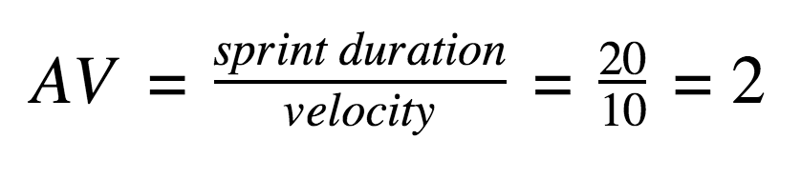

**Burndown Chart:**

A burn down chart is a graphical representation of work left to do versus time. It is often used in agile[software development](https://www.visual-paradigm.com/scrum/what-is-agile-software-development/) methodologies such as [Scrum](https://www.visual-paradigm.com/scrum/scrum-in-3-minutes/). However, burn down charts can be applied to any project containing measurable progress over time.

[**https://www.visual-paradigm.com/scrum/scrum-burndown-chart/**](https://www.visual-paradigm.com/scrum/scrum-burndown-chart/)

[**https://www.atlassian.com/agile/tutorials/burndown-charts**](https://www.atlassian.com/agile/tutorials/burndown-charts)

**Reference:**

[**https://www.atlassian.com/agile/project-management**](https://www.atlassian.com/agile/project-management)

[**https://www.atlassian.com/agile/tutorials/how-to-do-scrum-with-jira-software**](https://www.atlassian.com/agile/tutorials/how-to-do-scrum-with-jira-software)

[**https://www.atlassian.com/agile/tutorials/epics**](https://www.atlassian.com/agile/tutorials/epics)

[**https://www.atlassian.com/agile/tutorials/sprints**](https://www.atlassian.com/agile/tutorials/sprints)

[**https://www.atlassian.com/agile/project-management/estimation**](https://www.atlassian.com/agile/project-management/estimation)

[**https://www.atlassian.com/agile/tutorials/burndown-charts**](https://www.atlassian.com/agile/tutorials/burndown-charts)

**Project Design Phase**

**Proposed Solution Template**

|  |  |
| --- | --- |
| Date | 15 February 2025 |
| Team ID | LTVIP2025TMID32163 |
| Project Name | Smart SDLC – AI Enhanced Software Development Lifecycle |
| Maximum Marks | 2 Marks |

**Proposed Solution Template:**

Project team shall fill the following information in the proposed solution template.

|  |  |  |
| --- | --- | --- |
| **S.No.** | **Parameter** | **Description** |
|  | Problem Statement (Problem to be solved) | Many developers and learners struggle to understand and consistently follow SDLC practices due to fragmented tools and lack of contextual guidance. This leads to inefficiencies, poor software quality, and missed learning opportunities. |
|  | Idea / Solution description | Smart SDLC is an AI-powered assistant that provides phase-wise, contextual guidance throughout the Software Development Life Cycle, helping developers and learners implement best practices efficiently through intelligent automation. |
|  | Novelty / Uniqueness | Smart SDLC uniquely combines generative AI with phase-wise SDLC support, offering real-time, context-aware guidance that bridges the gap between theoretical knowledge and practical software development—something traditional tools lack. |
|  | Social Impact / Customer Satisfaction | Smart SDLC empowers learners and developers by making software engineering education more accessible and practical, reducing skill gaps. It enhances customer satisfaction by improving software quality, development efficiency, and user confidence through guided, AI-driven support. |
|  | Business Model (Revenue Model) | Smart SDLC follows a freemium model with premium subscriptions for full access. Revenue is generated through individual plans, institutional licenses for educational use, enterprise SaaS packages, and API integrations for third-party platforms. |
|  | Scalability of the Solution | Smart SDLC is highly scalable due to its cloud-based architecture, modular FastAPI backend, and AI-driven core. It can easily support increasing users, integrate with enterprise tools, and expand to cover additional software practices or domains. |

**Project Development Phase**

**Model Performance Test**

|  |  |
| --- | --- |
| Date | 21 February 2025 |
| Team ID | LTVIP2025TMID32163 |
| Project Name | Smart SDLC – AI Enhanced Software Development Lifecycle |
| Maximum Marks |  |

**Model Performance Testing:**

Project team shall fill the following information in model performance testing template.

|  |  |  |  |
| --- | --- | --- | --- |
| **S.No.** | **Parameter** | **Values** | **Screenshot** |
|  | Model Summary | Salesforce automation setup for Data management using Object, Fields and Reports.  **Note :** Import Records if data Match Correctly then Records will Created or Else it will Show Error |  |
|  | Accuracy | Training Accuracy - 98%  Validation Accuracy - 98% |  |
| 3. | Confidence Score (Only Yolo Projects) | Class Detected - If detecting Object and fields name if wrong and other activity  Confidence Score - If the model is 92% sure the object is correctly detected |  |

**Smart SDLC – AI Enhanced Software Development Lifecycle**

|  |  |
| --- | --- |
| Date | 31 January 2025 |
| Team ID | LTVIP2025TMID32163 |
| Project Name | Smart SDLC – AI Enhanced Software Development Lifecycle |
| Maximum Marks | 4 Marks |

**Prioritization Template:**

Smart SDLC is a generative AI-powered application developed using Fast-API and IBM's Granite-3.3-2b-instruct model. It provides phase-wise assistance across the Software Development Life-cycle (SDLC), enabling developers and learners to understand and implement software engineering practices through intelligent automation.

Reference: <https://www.mural.co/templates/brainstorm-and-idea-prioritization>

**Step-1: Team Gathering, Collaboration and Select the Problem Statement**

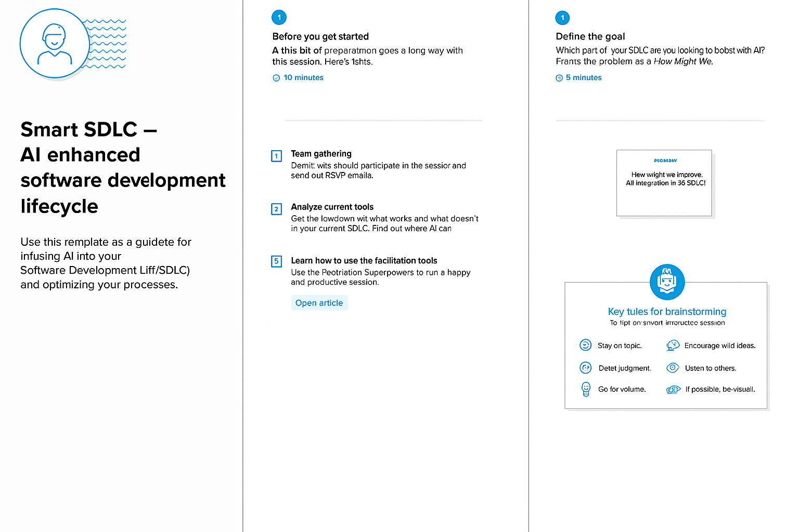

**Step-2: Idea Listing and Grouping**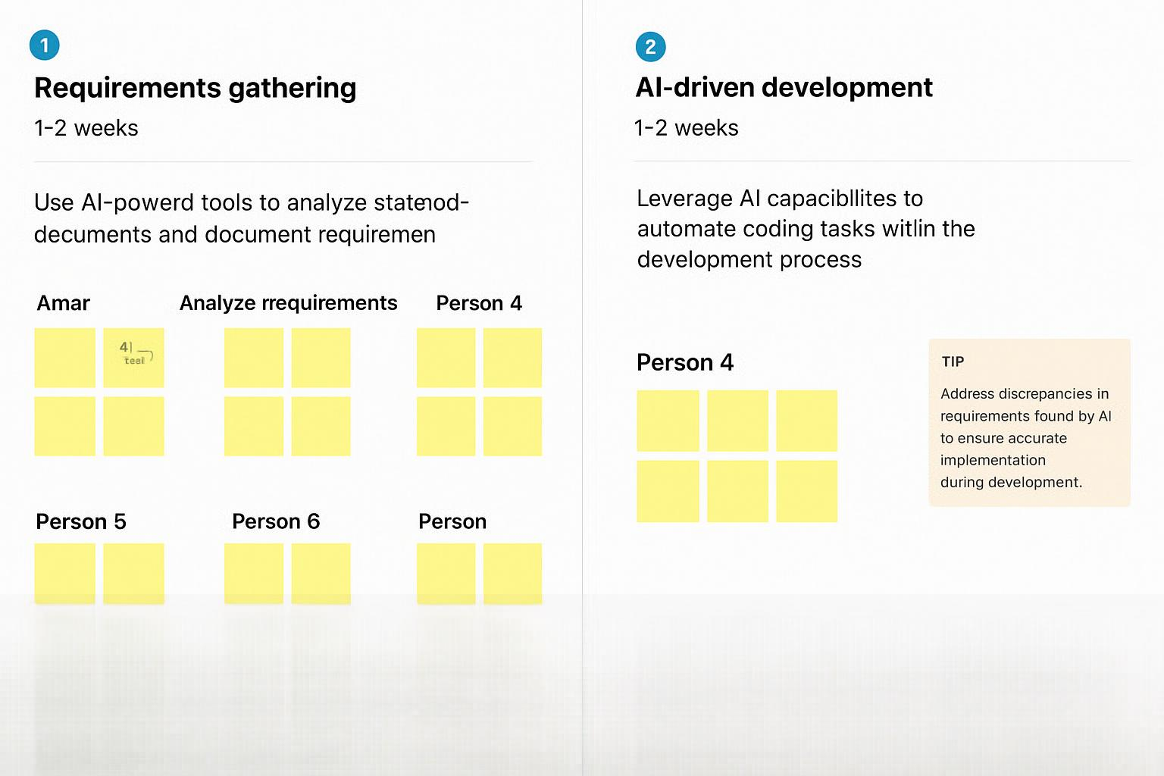

**Step-3: Idea Prioritization**

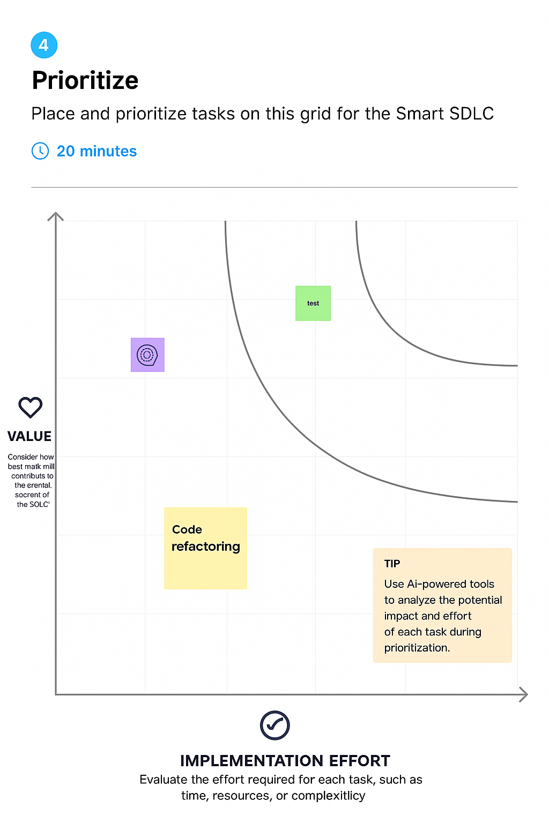

**Project Design Phase-II**

**Solution Requirements (Functional & Non-functional)**

|  |  |
| --- | --- |
| Date | 31 January 2025 |
| Team ID | LTVIP2025TMID32163 |
| Project Name | Smart SDLC – AI Enhanced Software Development Lifecycle |
| Maximum Marks | 4 Marks |

Here is the **Functional and Non-Functional Requirements** section tailored to the **Smart SDLC** application:

### ✅ **Functional Requirements**

Following are the functional requirements of the proposed **Smart SDLC** solution:

| **FR No.** | **Functional Requirement (Epic)** | **Sub Requirement (Story / Sub-Task)** |
| --- | --- | --- |
| FR-1 | User Registration | Registration through Form |
| Registration through Gmail |  |  |
| Registration through LinkedIn |  |  |
| FR-2 | User Confirmation | Confirmation via Email |
| Confirmation via OTP |  |  |
| FR-3 | SDLC Phase Assistance | Select SDLC phase (e.g., Design, Testing) |
| Input project context |  |  |
| Generate AI-guided suggestions |  |  |
| FR-4 | AI Integration | Connect to IBM Granite-3.3-2b-instruct |
| Process prompts per SDLC phase |  |  |
| Display formatted AI outputs |  |  |
| FR-5 | User Dashboard | View interaction history |
| Access AI responses |  |  |
| Track learning progress |  |  |
| FR-6 | Admin Panel | Manage user accounts |
| Monitor system usage |  |  |
| View analytics dashboard |  |  |

### 🔒 **Non-Functional Requirements**

Following are the non-functional requirements of the proposed **Smart SDLC** system:

| **NFR No.** | **Non-Functional Requirement** | **Description** |
| --- | --- | --- |
| NFR-1 | Usability | The system should have a clean, intuitive UI for both developers and learners. |
| NFR-2 | Security | User data and AI interactions must be securely handled using encryption and auth mechanisms. |
| NFR-3 | Reliability | The system should function correctly under defined conditions without failure. |
| NFR-4 | Performance | Responses from the AI engine and API should be delivered with minimal latency. |
| NFR-5 | Availability | The system should be accessible 24/7 with minimal downtime. |
| NFR-6 | Scalability | The system should support growing numbers of users and requests without degradation. |

**Project Design Phase**

**Solution Architecture**

|  |  |
| --- | --- |
| Date | 15 February 2025 |
| Team ID | LTVIP2025TMID32163 |
| Project Name | Smart SDLC – AI Enhanced Software Development Lifecycle |
| Maximum Marks | 4 Marks |

### **Solution Architecture: Smart SDLC**

**Objective:**  
To bridge the gap between complex software development processes and accessible, AI-powered guidance for developers and learners.

### **Key Components:**

* **Frontend Interface:**  
  Intuitive UI for interacting with users across SDLC phases, built using modern web frameworks (e.g., React or minimal UI via FastAPI).
* **Backend Engine (FastAPI):**  
  Lightweight, high-performance Python framework handling user requests, session states, and orchestration of AI responses.
* **AI Model Integration:**  
  IBM Granite-3.3-2b-instruct model provides generative responses tailored to each SDLC phase—requirement analysis, design, development, testing, deployment, and maintenance.
* **Phase-wise Logic Layer:**  
  Business logic that maps user inputs and project context to relevant SDLC stages, guiding decision-making intelligently.
* **Data Layer (optional for scalability):**  
  Stores project history, user preferences, or learning paths to personalize the experience.

### **Architecture Goals:**

✅ Deliver contextual, real-time support for each SDLC phase  
✅ Enable modular feature expansion (e.g., plug-in DevOps or test automation)  
✅ Ensure scalability for individual, institutional, or enterprise use  
✅ Provide an explainable AI layer to maintain trust and clarity in responses

**Example - Solution Architecture Diagram:**

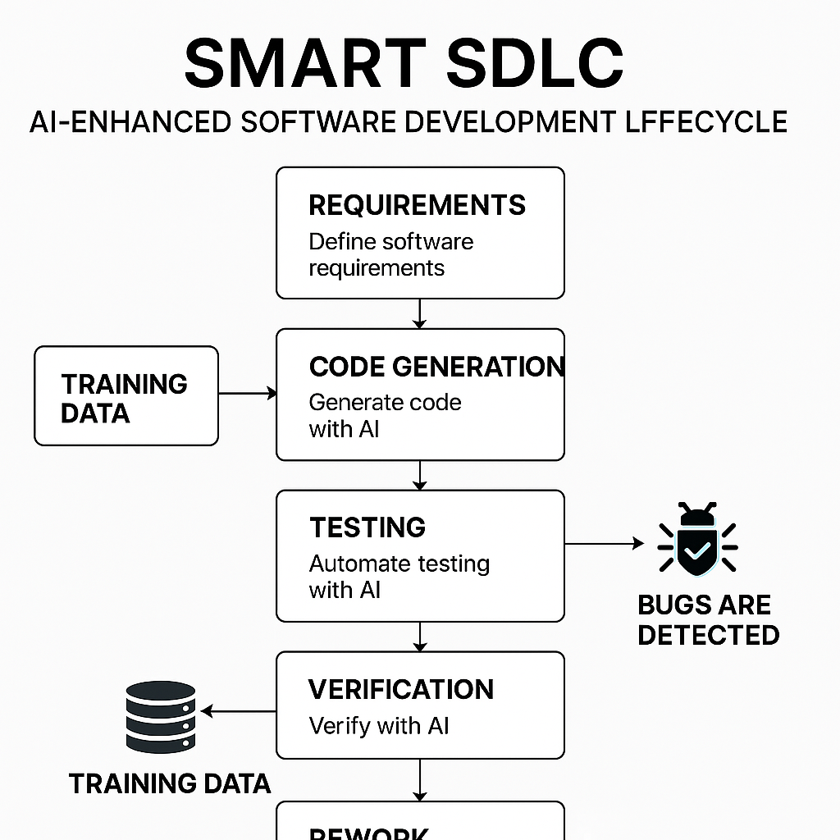

*Figure 1: Architecture and data flow of the voice patient diary sample application*

**Reference:** [**https://aws.amazon.com/blogs/industries/voice-applications-in-clinical-research-powered-by-ai-on-aws-part-1-architecture-and-design-considerations/**](https://aws.amazon.com/blogs/industries/voice-applications-in-clinical-research-powered-by-ai-on-aws-part-1-architecture-and-design-considerations/)

**Project Design Phase-II**

**Technology Stack (Architecture & Stack)**

|  |  |
| --- | --- |
| Date | 31 January 3035 |
| Team ID | LTVIP2025TMID32163 |
| Project Name | Smart SDLC – AI Enhanced Software Development Lifecycle |
| Maximum Marks | 4 Marks |

**Technical Architecture:**

The Deliverable shall include the architectural diagram as below and the information as per the table1 & table 2

**Example: Order processing during pandemics for offline mode**

**Reference:** [**https://developer.ibm.com/patterns/ai-powered-backend-system-for-order-processing-during-pandemics/**](https://developer.ibm.com/patterns/ai-powered-backend-system-for-order-processing-during-pandemics/)

### **Guidelines: Smart SDLC – AI Enhanced Software Development Lifecycle**

* **Include all the processes (As an application logic / Technology Block):**
  + User Interface – React JS
  + Backend API Engine – FastAPI (Python)
  + Prompt Generator – Custom Python Logic
  + AI Integration Layer – IBM Granite-3.3-2b-instruct API
  + Authentication – OAuth 2.0 / JWT
  + Response Formatter – Python Formatter
  + Logging & History – Python Logging + MongoDB
* **Provide infrastructural demarcation (Local / Cloud):**
  + UI hosted on **Cloud** (Vercel / Netlify / IBM Cloud)
  + Backend deployed on **Cloud or Local** (Render / IBM Cloud Foundry / Docker)
  + AI Model accessed from **IBM Cloud**
  + Database hosted on **Cloud** (IBM Cloudant / Firebase) or **Local** (MongoDB / SQLite)
* **Indicate external interfaces (third party API’s etc.):**
  + IBM Granite AI Model API
  + Google / GitHub OAuth API for login
  + GitHub API (optional for project integration)
* **Indicate Data Storage components / services:**
  + MongoDB / Firebase for user data and session storage
  + IBM Cloud Object Storage / Local Filesystem for logs and files
  + Redis (optional) for caching AI responses
* **Indicate interface to machine learning models (if applicable):**
  + Prompts are sent to IBM Granite-3.3-2b-instruct via secured API
  + AI responses are processed and returned to the user via FastAPI

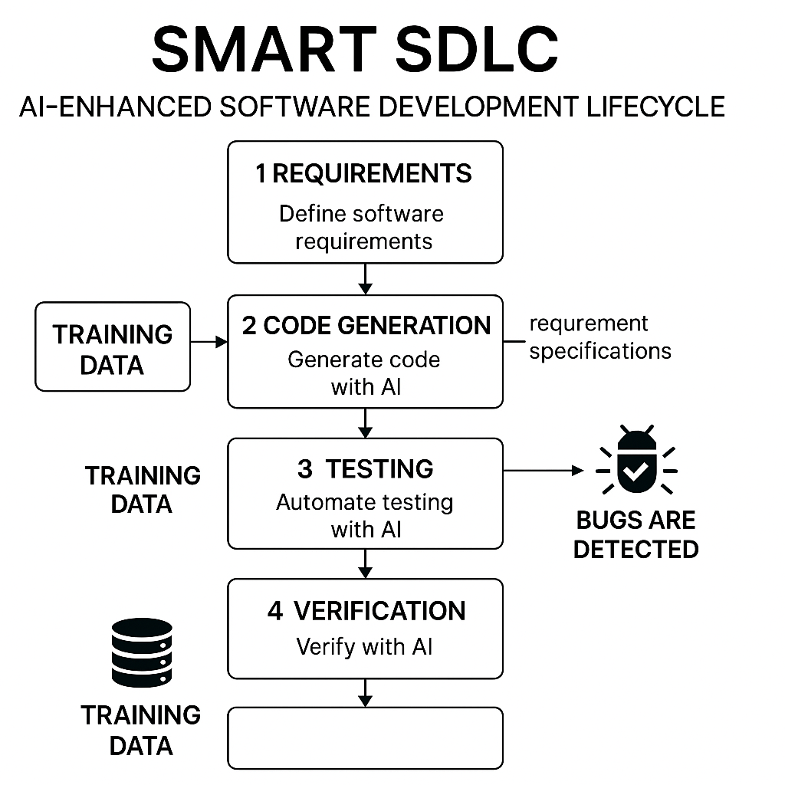

Certainly! Below are **Table-1 (Components & Technologies)** and **Table-2 (Application Characteristics)** specifically tailored for the **Smart SDLC** application.

### ✅ **Table-1: Components & Technologies**

| **S.No** | **Component** | **Description** | **Technology** |
| --- | --- | --- | --- |
| 1. | User Interface | Web-based UI for interaction with SDLC assistant | HTML, CSS, JavaScript, React JS |
| 2. | Application Logic-1 | Core API handling and routing logic | Python, FastAPI |
| 3. | Application Logic-2 | AI prompt generation and request formatting | Custom Python Modules |
| 4. | Application Logic-3 | Integration with generative AI model | IBM Granite-3.3-2b-instruct Model (via API) |
| 5. | Database | Store user sessions or interactions (optional) | MongoDB / SQLite |
| 6. | Cloud Database | Scalable cloud-based DB for persistent data (optional) | IBM Cloudant / Firebase Firestore |
| 7. | File Storage | Store logs, user uploads, model outputs (if needed) | IBM Cloud Object Storage / Local File System |
| 8. | External API-1 | Project metadata enrichment (optional feature) | GitHub API (for repo integration) |
| 9. | External API-2 | Authentication via Google/GitHub | OAuth2 APIs |
| 10. | Machine Learning Model | AI model used for contextual SDLC assistance | IBM Granite-3.3-2b-instruct (Generative LLM) |
| 11. | Infrastructure | Hosting and deployment environment | IBM Cloud Foundry, Docker, Render, or Kubernetes Cluster |

### ✅ **Table-2: Application Characteristics**

| **S.No** | **Characteristics** | **Description** | **Technology / Implementation** |
| --- | --- | --- | --- |
| 1. | Open-Source Frameworks | Core backend and frontend frameworks used | FastAPI (Python), React JS, MongoDB |
| 2. | Security Implementations | Securing APIs and data with modern standards | OAuth2, JWT Authentication, HTTPS, Input Validation |
| 3. | Scalable Architecture | Modular & extensible architecture for scale-out scenarios | Microservices (FastAPI modules), Docker, Kubernetes |
| 4. | Availability | Ensures continuous uptime and access | Load Balancers, Cloud Auto-Scaling, Health Monitoring Tools |
| 5. | Performance | Optimized for high responsiveness and concurrent requests | Caching (Redis), Async I/O (FastAPI), CDN (if static files) |

**References:**

[**https://c4model.com/**](https://c4model.com/)

[**https://developer.ibm.com/patterns/online-order-processing-system-during-pandemic/**](https://developer.ibm.com/patterns/online-order-processing-system-during-pandemic/)

[**https://www.ibm.com/cloud/architecture**](https://www.ibm.com/cloud/architecture)

[**https://aws.amazon.com/architecture**](https://aws.amazon.com/architecture)

[**https://medium.com/the-internal-startup/how-to-draw-useful-technical-architecture-diagrams-2d20c9fda90d**](https://medium.com/the-internal-startup/how-to-draw-useful-technical-architecture-diagrams-2d20c9fda90d)